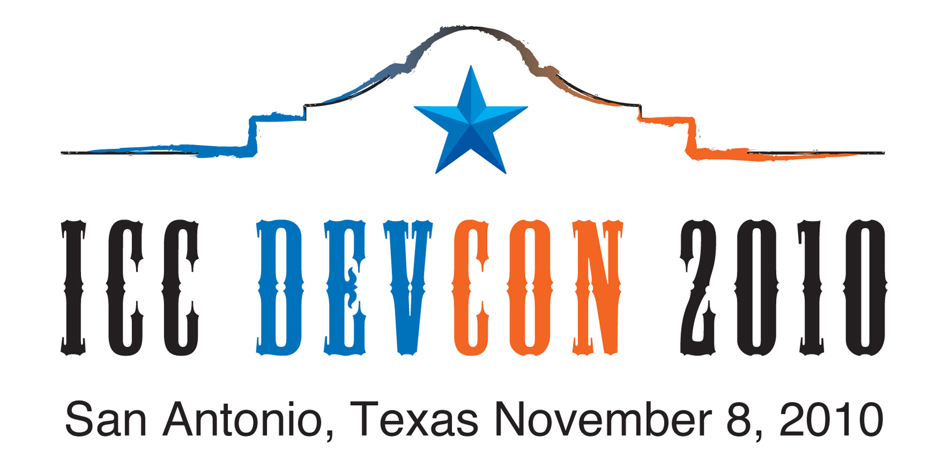

Sponsorship Enrollment Form

Check one: ( ) Platinum Level—includes 2 attendees--$2,000.00

( ) Diamond Level—includes 1 attendees--$1,000.00

( ) Gold Level--$500.00

Fax completed form to: Kip Smythe, ICC Secretary (703) 620-0994

Company____________________________________________________________

Primary contact:

Name_______________________________________________________________

Title________________________________________________________________

Address_____________________________________________________________

City____________________________State____________Zip code_____________

Country (if not USA)__________________________________________________

Phone_____________________________Fax______________________________

Email______________________________________________________________

Please send an electronic copy of your company’s logo for promotional use in conjunction with ICC DevCon 2010 to ksmythe@npes.org.

Second attendee(Platinum sponsors only):

Name_______________________________________________________________

Title________________________________________________________________

Phone_____________________________Fax_______________________________

Email_______________________________________________________________

Payment Options

Sorry, NPES cannot bill you. The fee must accompany this registration form. Please pay by credit card or enclose check in U.S. funds drawn on a U.S. bank payable to NPES.
Visa/MasterCard/American Express/Discover Card/Carte Blanche/Diners Club

Card # ______________________________________________________________

Verification #_____________________________ Expiration Date ____________

Card Holder’s Name___________________________________________________

Card Holder’s Signature________________________________________________

Total dollar amount authorized for charge $ _______________________________

-----------------------------------------------------------------------------------------------------------------------

International Color Consortium
c/o NPES
1899 Preston White Drive
Reston, VA 20191
(703) 264-7200
$50

